
Final Details – Lossiemouth Forest – 20th September 2026

Event Safety

- Competitors. Participants take part at their own risk and are responsible for their own safety at all times. All participants are to wear suitable footwear and full leg cover.
- Terrain Hazards. Participants are advised that they will encounter gorse, brash, tree stumps and tree roots on the courses
- Weather. Waterproof may be compulsory in the event of inclement weather, a sign at assembly will be displayed as required
- Dis-orientation. Safety bearing is due South until reach the main forest road, then proceed back to parking field
- Vehicle Movements. Participants are advised walks to start and return from finish cross the main forest road, there can be slow moving quarry traffic.
- Ticks. Please check yourselves carefully after your run and remove them as soon as possible, and ideally within 48 hours.
- First Aid. A first aid kit will be available at registration as and if required. The nearest hospital is Dr Gray’s in Elgin (15 mins drive away).

Cake
- Anne Parkinson has kindly offered to provide a cake stall at registration. Please come with some cash.

Directions

- Registration, download and parking will all be in a field at Cotts of Innes.
  - Google maps https://maps.app.goo.gl/TqeyVu7HYkrWxkeP6
  - What3Words ///oxidation.royal.breakfast
- Please follow the highlighted route to parking field. These are very narrow lanes and the final stretch is track. Please drive slowly.
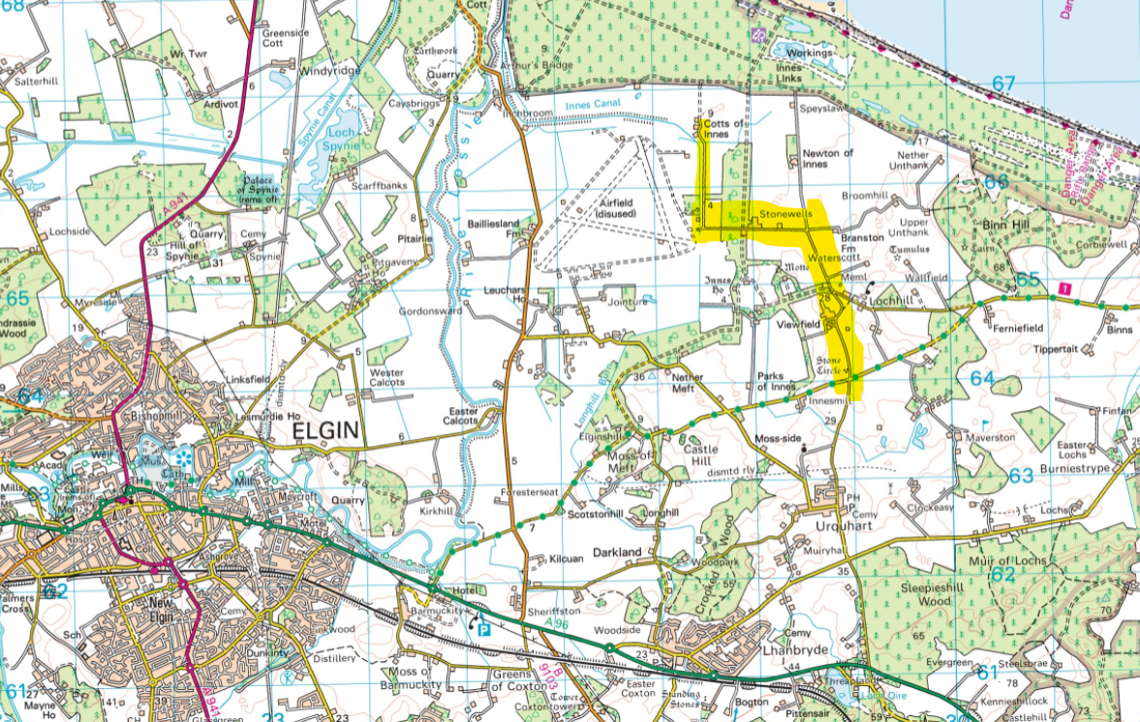

- From Urquhart village proceed north going straight over at cross roads towards Lochill
- Continue north proceeding past a dead end sign
- You will reach a 90 degree corner to the left at a junction with tracks. Continue along this road to the left until you see a gate with a track to the right at the end of the road.
- Proceed along the track to the parking field
- There will be signage from the junction with the stone circle to assist

Parking

- Car parking is available in a field with registration and download. It will be self-parking, please do so considerately.
- If there is very heavy rain in the days prior to the event, parking will relocate to the old airfield, further details will be issued if this is required. It will elongate the walks to the start.

Registration/Download

- The event registration and download will be in the field at Cotts of Innes (Grid Ref NJ 274 664; what3words: ///oxidation.royal.breakfast
- Hired SI dibbers will be available for collection at Registration.
- Yellow maps will be collected from Registration

Start

- The start is 700m from registration

Finish

- The finish is near the start
- On finishing, all competitors must report to download in registration – even if you retire and do not complete your course.
- All courses close at 1345. At this time, all competitors on the course must return to registration and report to download.

Timing

- SI AIR will be enabled for the event.
- Participants must physically dib the start and finish SI units to start/finish their timings.

Additional Information

- Toilets. There are no toilets available at the field
- Refreshments. Anne Parkinson has kindly offered to run a cake stall, please bring some cash
- Other Forest Users. Please respect other users of the Forest (dog walkers, horse riders and cyclists)
- Car Keys. Can be left at registration at owners own risk.
- Litter. All competitors are asked to take their litter home with them.
- Dogs. Dogs are welcome but must be kept on leads.

Moravian Orienteers

Organiser: Louisa Ross
Organisers Phone: 07595644448
Organisers Email: secretary@mor.scot
Planner: David Ritchie and Dougie Condie

